Lab: Batch Scoring in DSX

November 30th, 2017

Author: Elena Lowery elowery@us.ibm.com
Table of contents
Contents
Overview 1
Required software, access, and files 1
Part 1: Load the sample project and create model 1
Part 2: Configure batch scoring of a model 2
Part 3: Configure batch scoring of a notebook 5

Overview
In this lab you will learn how to configure batch scoring in DSX.

Required software, access, and files
- To complete this lab, you will need access to a DSX Local cluster.
- You will also need to download and unzip this GitHub repository: https://github.com/elenalowery/DSX_Local_Workshop

Part 1: Load the sample project and create model

- If you haven’t already created a project from DSX_Local_Workshop.zip file, follow instructions for Use Case 1 in this repository https://github.com/elenalowery/DSX_Local_Workshop

- If you haven’t run through the TelcoChurn notebook, run through it so that you generate a model. The easiest way to do this is to open the notebook, scroll down to Step 10, click on it, then in the menu select Cell -> Run all above.

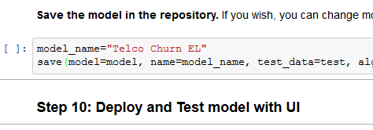

Navigate to the Assets view and make sure that the model has been created. Your model may have a different name and version.

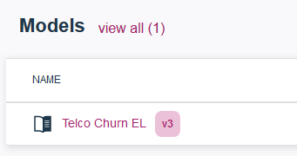

Part 2: Configure batch scoring of a model

- Click on the ellipses next to the model and select Batch Score.

- Fill out the required fields:

  - Execution type: DSX
  - Input data set: new_customer_churn_data.csv (this data set contains data that should be scored)
  - Output data set: ScoringResults.csv. Make sure to provide .csv extension – otherwise you won’t be able to preview and download the output.

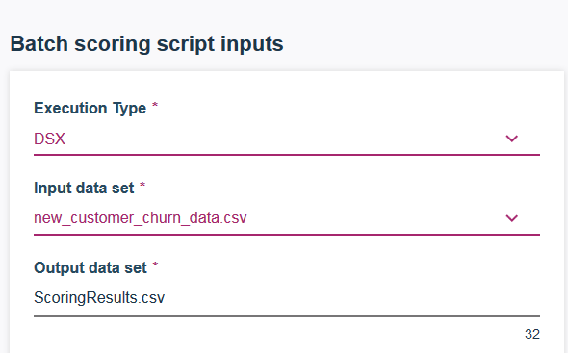

Click Generate Batch Script. Then click Save as. Keep the File type .py and provide File name for the script, for example ScoreTelcoCustomers. Click Save and create job.

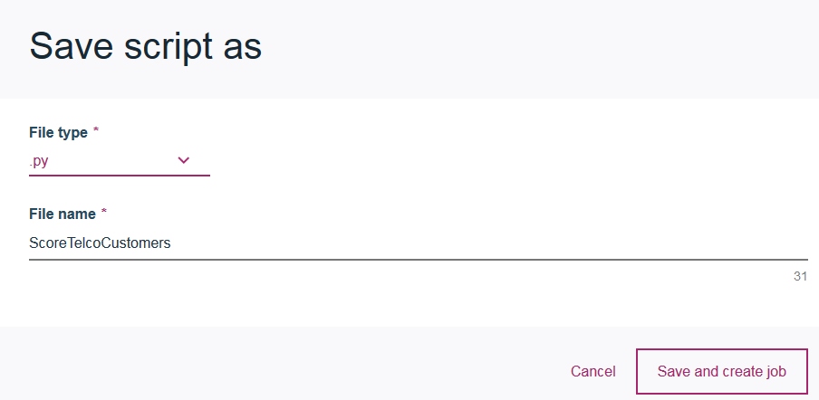

- On the Create Job screen provide Job name and make sure to select the right Worker (Python 2.x or 3.x) environment (check comments in the notebook or check with the instructor). Click Create.

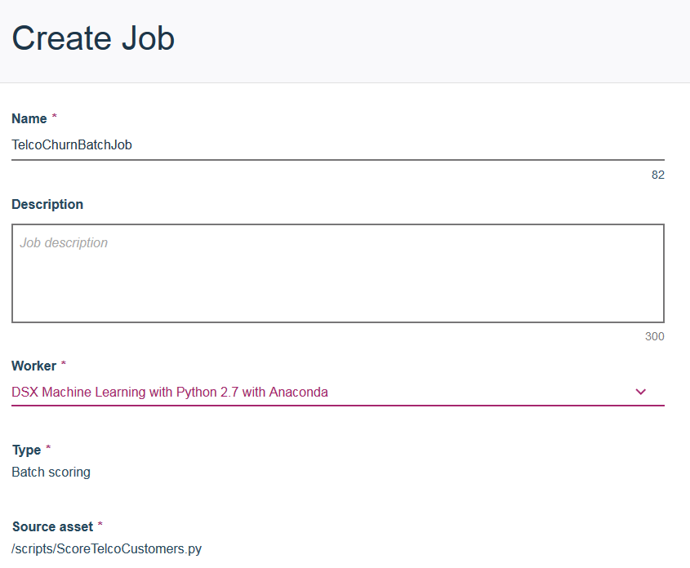

- In the Batch Job Details view scroll down and select Run Now.

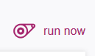

- Provide Run name and click Run.

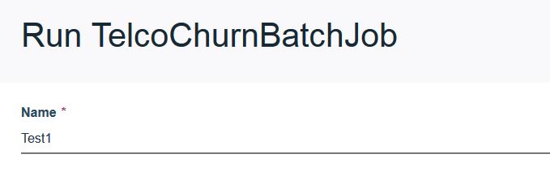

- Job status is displayed.

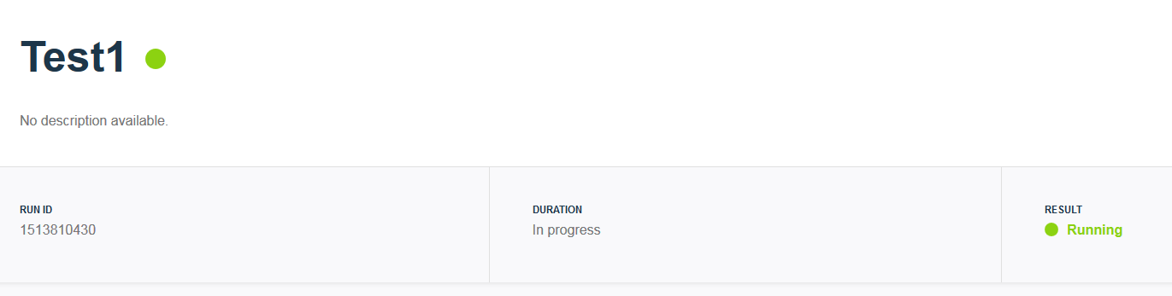

- Navigate back to the Batch Job Details view to verify that the job ran successfully.

- Navigate to the Assets view of the project. Scroll down to Data Sets. You should see the generated ScoringResults.csv file.

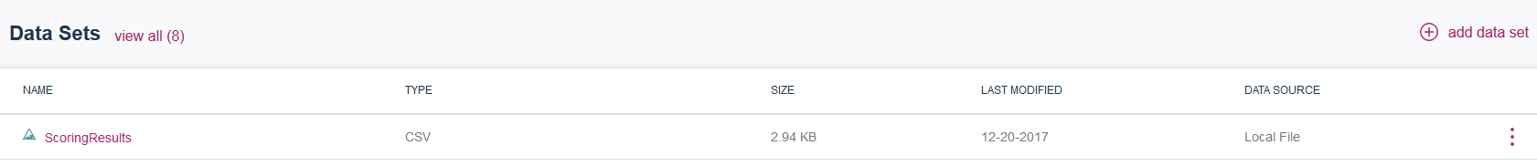

- You can choose to preview or download the file (click on the ellipses). The scoring results are the last few columns: rawPrediction, probability, prediction, predictedLabel.

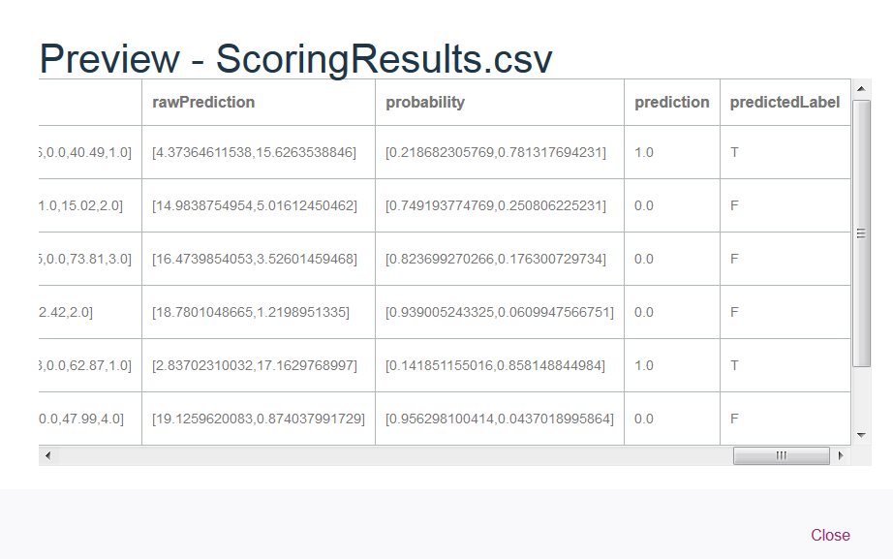

Part 3: Configure batch scoring of a notebook

- Navigate to the Project view then click on Jobs.

- Click create job.

- Enter Job information. Make sure to select Worker that matches version of Python in the notebook. Click Create.

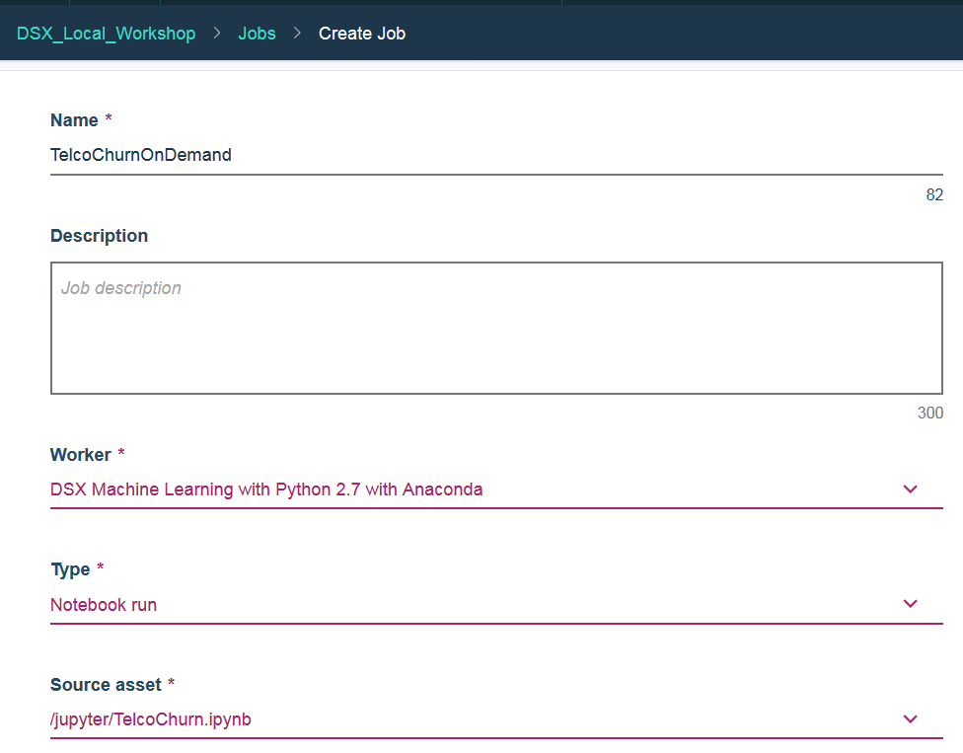

- In the Batch Job Details view scroll down and select Run Now.

- Provide Run name and click Run.

- Job status is displayed.

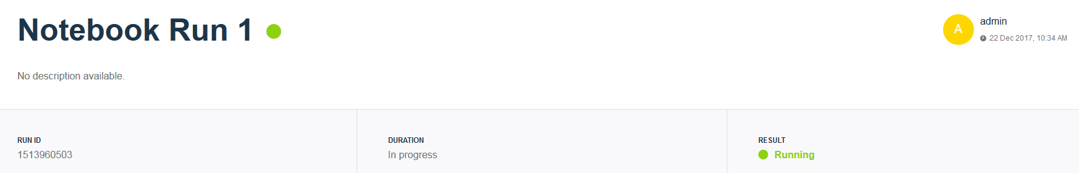

- Navigate back to the Batch Job Details view to verify that the job ran successfully. You can also verify that the notebook ran by checking the version of the model in the Project view – it should be incremented.

You have finished working on Batch Scoring in DSX lab.

